SQL Database Commands
# Source: AI Source: Provided by: [Data Path: Persons Table -> ID Column: 1, Name_En Column: Motasem Essam] -> From: [ChatGPT] on [6/11/2026]
In SQL, CREATE DATABASE is used to create a new database, and DROP DATABASE is used to delete an existing database.

Create a Database
# Source: AI Source: Provided by: [Data Path: Persons Table -> ID Column: 1, Name_En Column: Motasem Essam] -> From: [ChatGPT] on [6/11/2026]
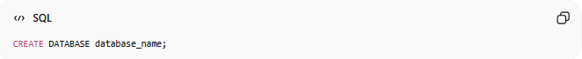
CREATE DATABASE database_name;
Example:
CREATE DATABASE CompanyDB;
This creates a new database named CompanyDB.

Real Example

basic command
# Source: ScreenShot Source: Provided by: [Persons Table -> ID Column: 1, Name_En Column: Motasem Essam] -> Tool: [Automation Table -> ID Column: 16, Name_En Column: Screen Capture] -> From [Operating System: Wampserver64 -> phpmyadmin] on [6/11/2026]
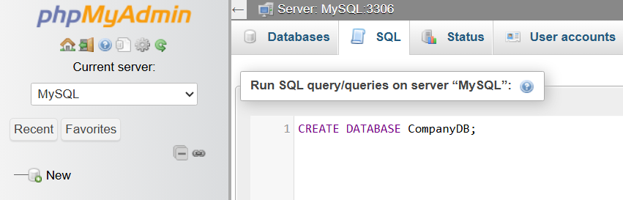
CREATE DATABASE CompanyDB;
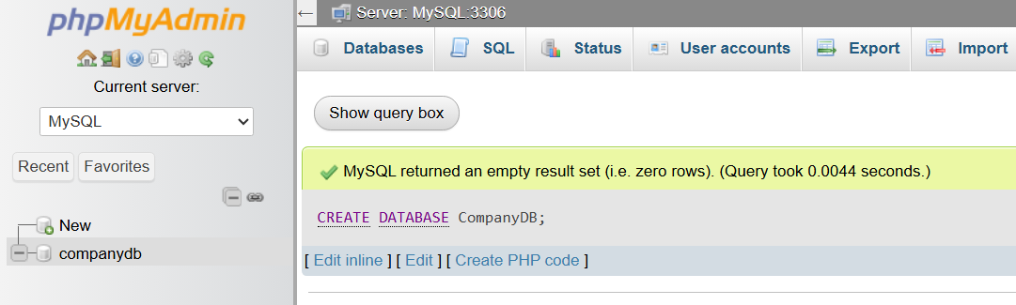

Drop a Database
# Source: AI Source: Provided by: [Data Path: Persons Table -> ID Column: 1, Name_En Column: Motasem Essam] -> From: [ChatGPT] on [6/11/2026]
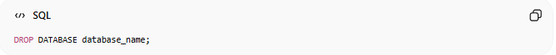
DROP DATABASE database_name;
Example:
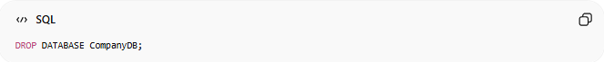
DROP DATABASE CompanyDB;
This permanently deletes the CompanyDB database and all its data.

Real Example

prepared commands
# Source: ScreenShot Source: Provided by: [Persons Table -> ID Column: 1, Name_En Column: Motasem Essam] -> Tool: [Automation Table -> ID Column: 16, Name_En Column: Screen Capture] -> From [Operating System: Wampserver64 -> phpmyadmin] on [6/11/2026]

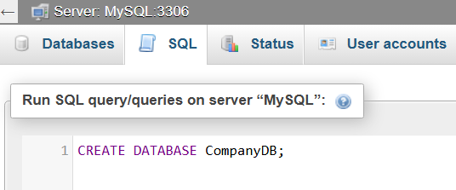
CREATE DATABASE CompanyDB;


basic command
# Source: ScreenShot Source: Provided by: [Persons Table -> ID Column: 1, Name_En Column: Motasem Essam] -> Tool: [Automation Table -> ID Column: 16, Name_En Column: Screen Capture] -> From [Operating System: Wampserver64 -> phpmyadmin] on [6/11/2026]
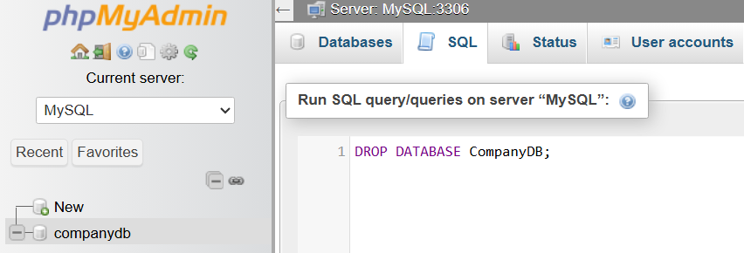
DROP DATABASE CompanyDB;

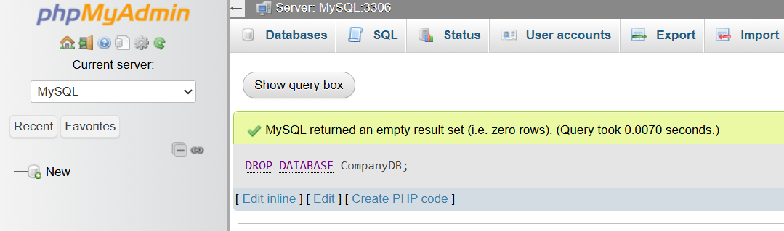

Check Existing Databases (common SQL syntax)
# Source: AI Source: Provided by: [Data Path: Persons Table -> ID Column: 1, Name_En Column: Motasem Essam] -> From: [ChatGPT] on [6/11/2026]
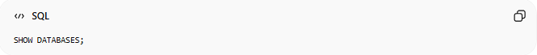
SHOW DATABASES;

Real Example

prepared commands
# Source: ScreenShot Source: Provided by: [Persons Table -> ID Column: 1, Name_En Column: Motasem Essam] -> Tool: [Automation Table -> ID Column: 16, Name_En Column: Screen Capture] -> From [Operating System: Wampserver64 -> phpmyadmin] on [6/11/2026]


CREATE DATABASE CompanyDB;


basic command
# Source: ScreenShot Source: Provided by: [Persons Table -> ID Column: 1, Name_En Column: Motasem Essam] -> Tool: [Automation Table -> ID Column: 16, Name_En Column: Screen Capture] -> From [Operating System: Wampserver64 -> phpmyadmin] on [6/11/2026]
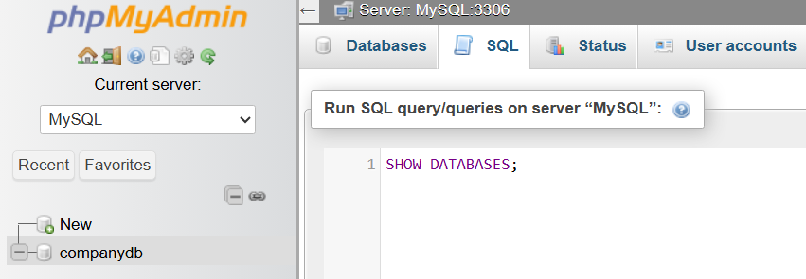
SHOW DATABASES;
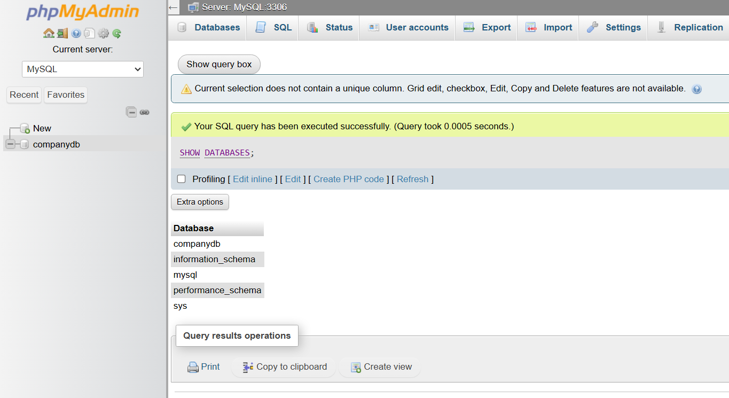

Select a Database
# Source: AI Source: Provided by: [Data Path: Persons Table -> ID Column: 1, Name_En Column: Motasem Essam] -> From: [ChatGPT] on [6/11/2026]
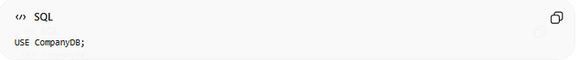
USE CompanyDB;

Real Example

prepared commands
# Source: ScreenShot Source: Provided by: [Persons Table -> ID Column: 1, Name_En Column: Motasem Essam] -> Tool: [Automation Table -> ID Column: 16, Name_En Column: Screen Capture] -> From [Operating System: Wampserver64 -> phpmyadmin] on [6/11/2026]


CREATE DATABASE CompanyDB;


basic command
# Source: ScreenShot Source: Provided by: [Persons Table -> ID Column: 1, Name_En Column: Motasem Essam] -> Tool: [Automation Table -> ID Column: 16, Name_En Column: Screen Capture] -> From [Operating System: Wampserver64 -> phpmyadmin] on [6/11/2026]
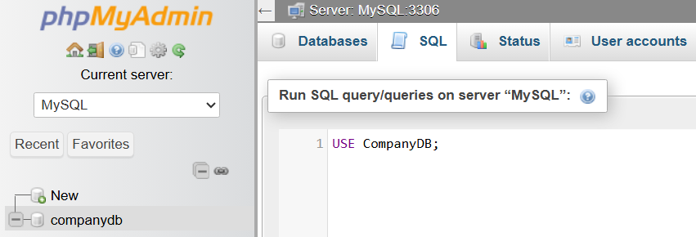
USE CompanyDB;
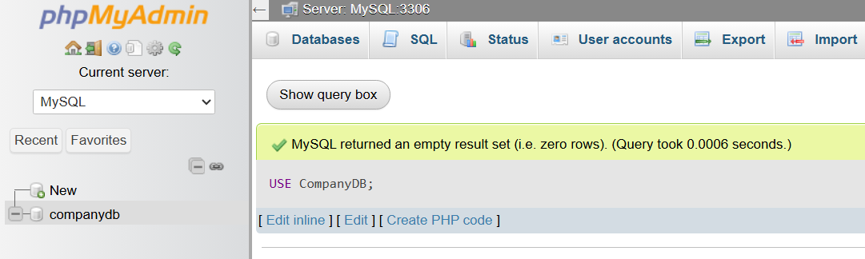

Important Notes
# Source: AI Source: Provided by: [Data Path: Persons Table -> ID Column: 1, Name_En Column: Motasem Essam] -> From: [ChatGPT] on [6/11/2026]
- You usually need administrative privileges to create or drop databases.
- DROP DATABASE is irreversible in most systems unless you have a backup.
- Use the USE command to select a database before creating tables, inserting data, or running queries on that database.
- Once a database is selected, all subsequent SQL statements are executed within that database until another database is selected.
- Some SQL systems support conditional statements:
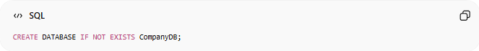
CREATE DATABASE IF NOT EXISTS CompanyDB;
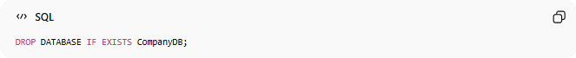
DROP DATABASE IF EXISTS CompanyDB;
These help avoid errors if the database already exists or does not exist.

